SANDWICH MAP

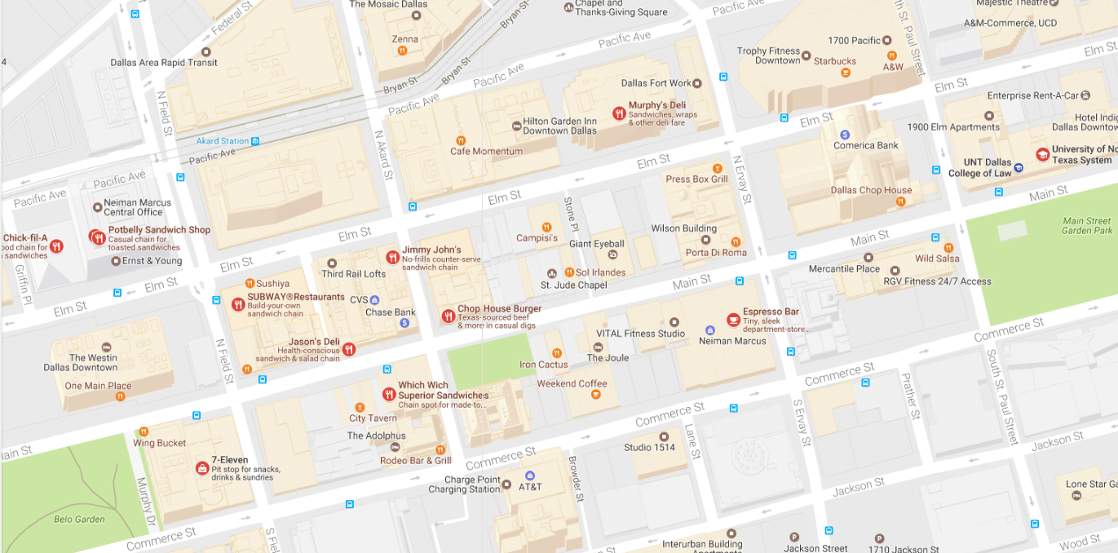

UNT LLLLLLLLLAWLLLL

MEXICAN/TEX-MEX MAP

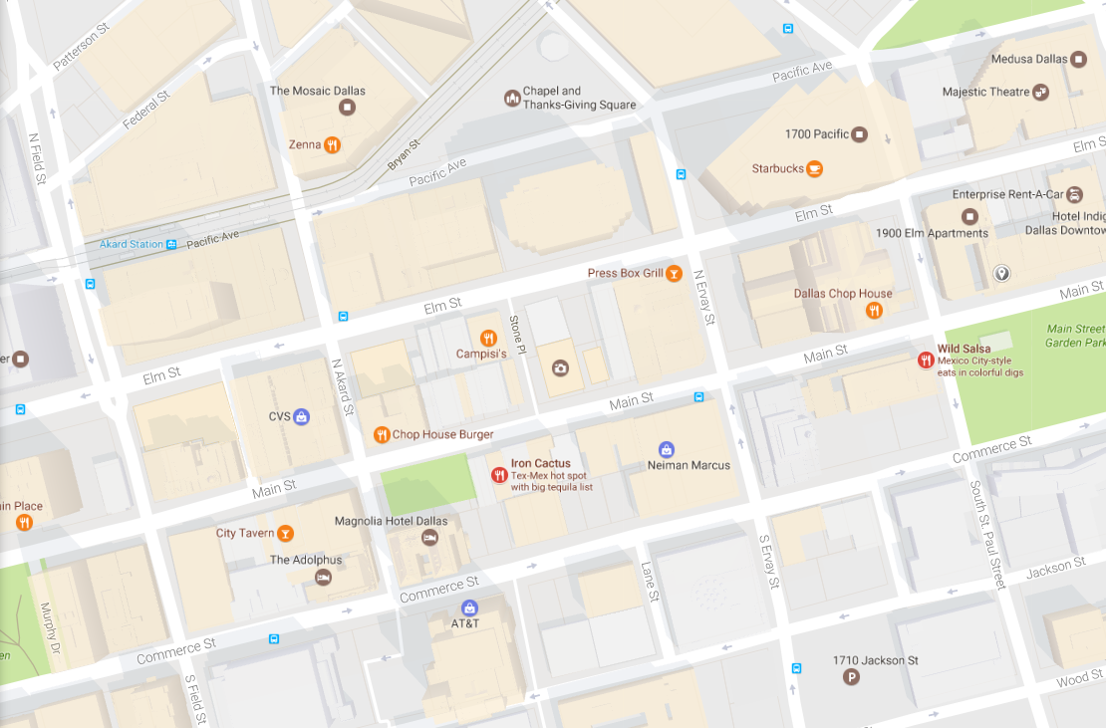

UNT

ASIAN MAP

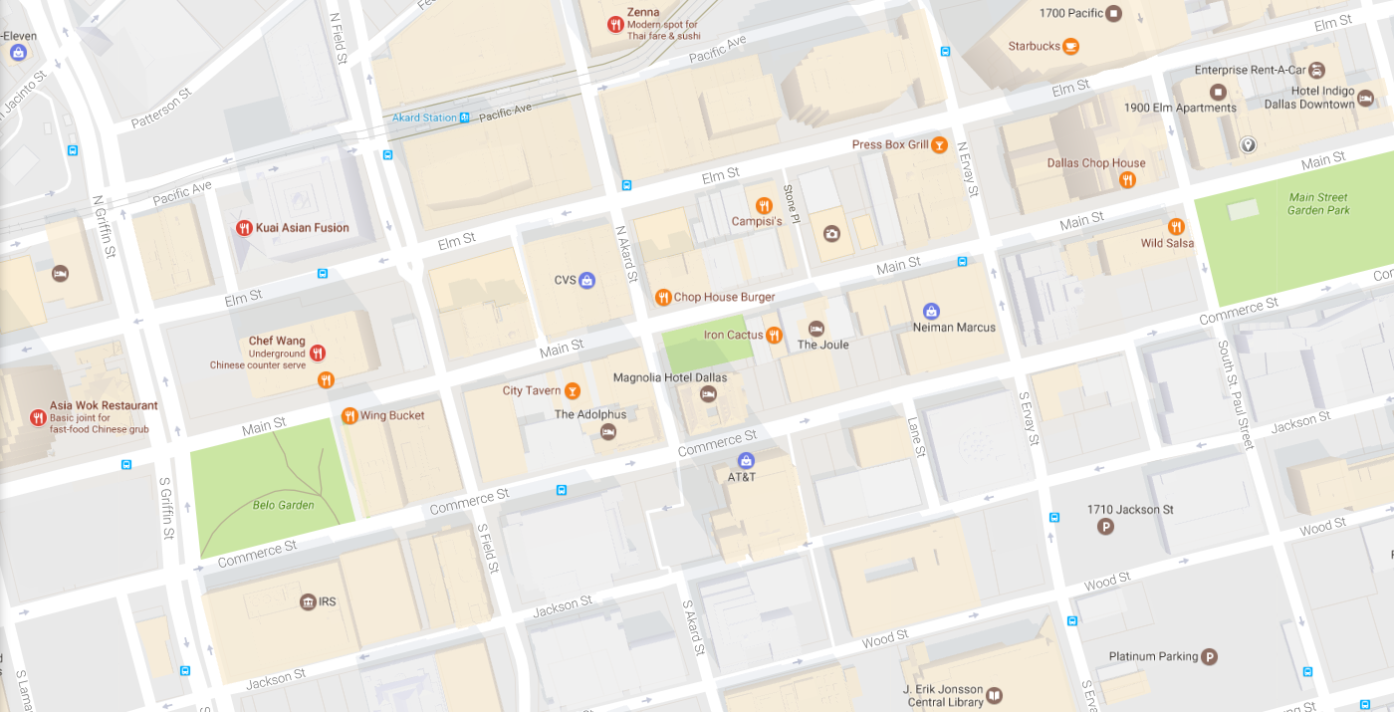

UNT

STEAKHOUSES MAP

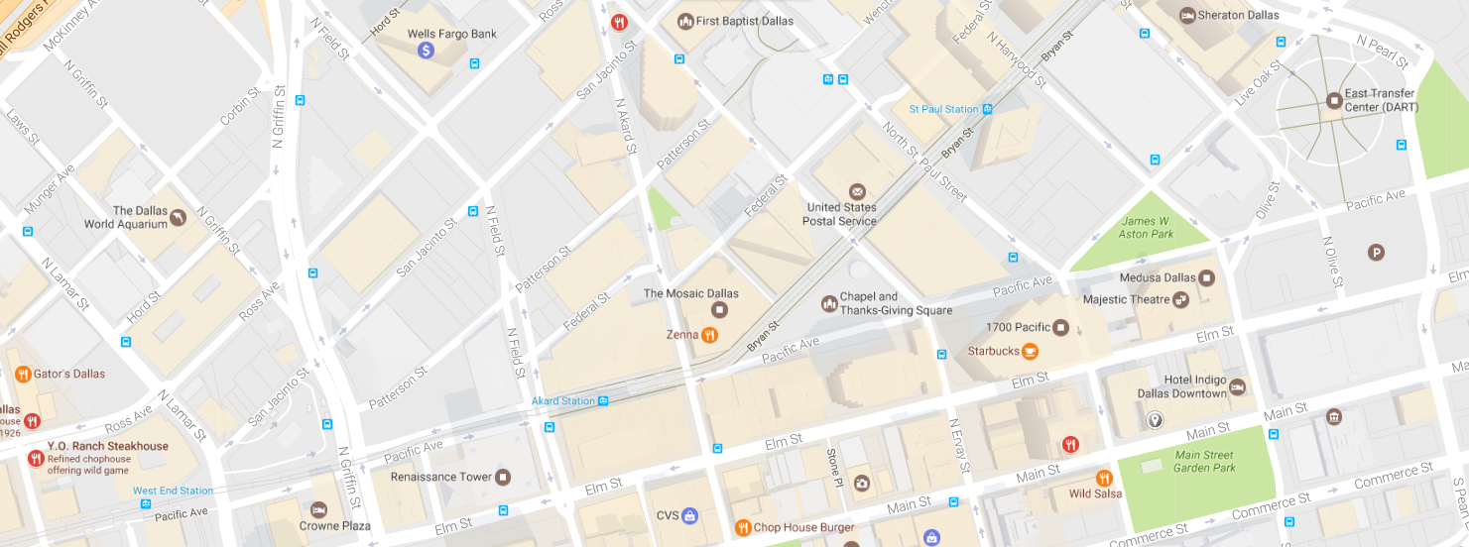

UNT

HEALTHY MAP

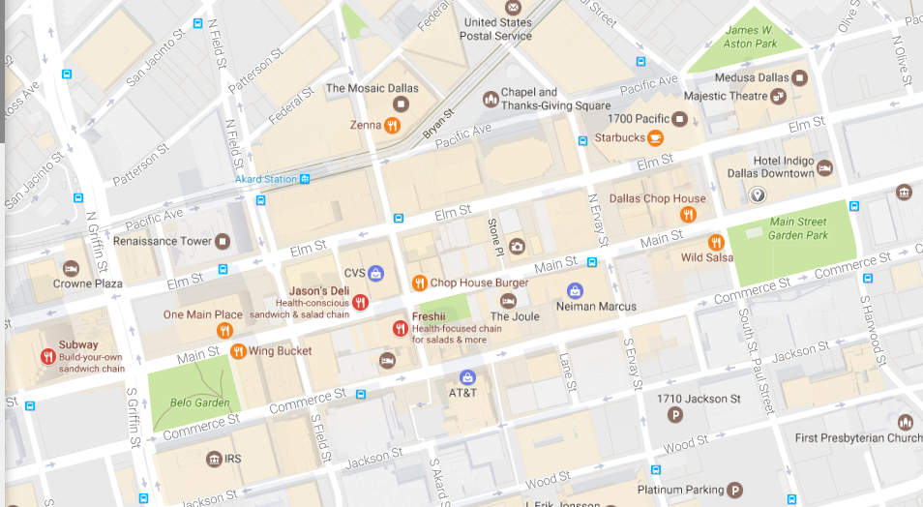

UNT

ITALIAN MAP

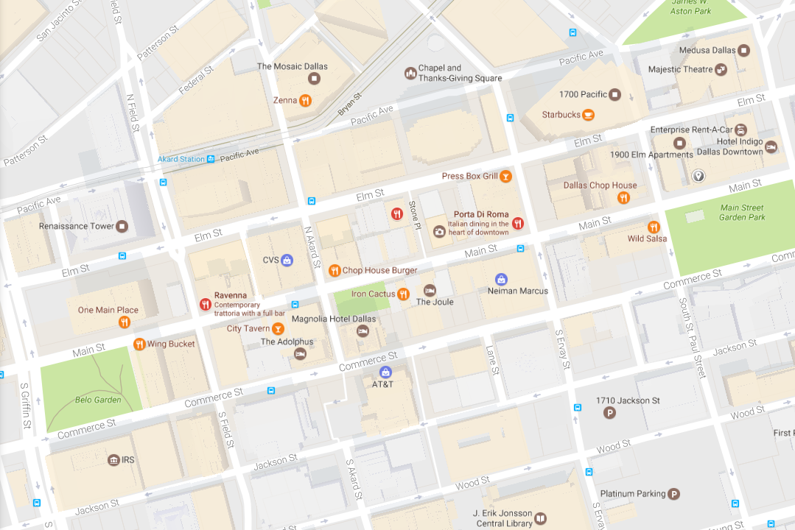

UNT

AMERICAN MAP

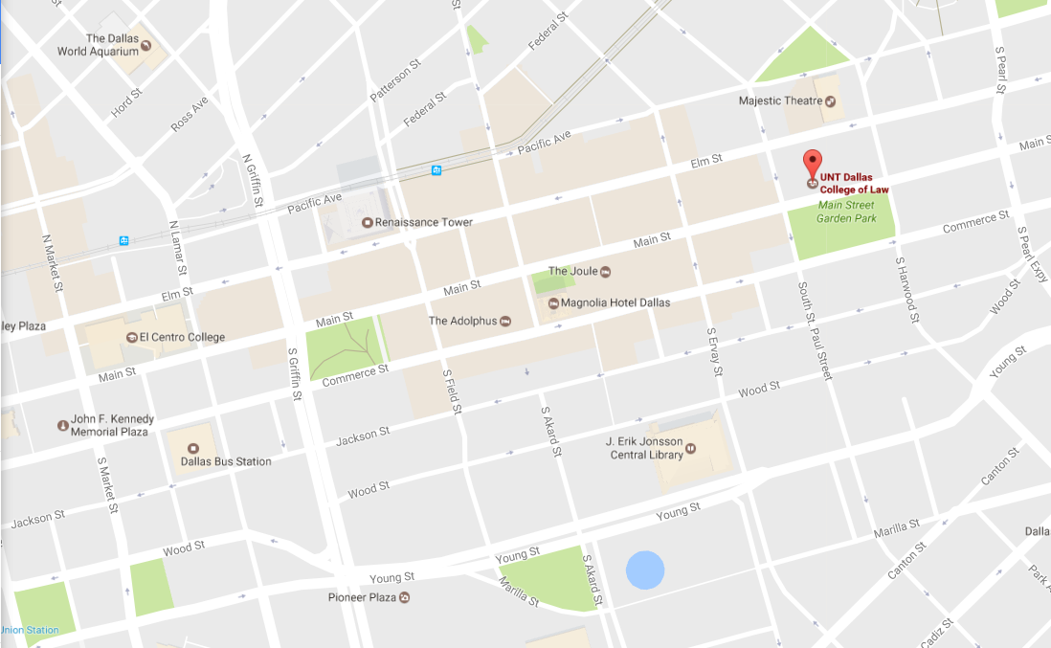

COFFEE MAP 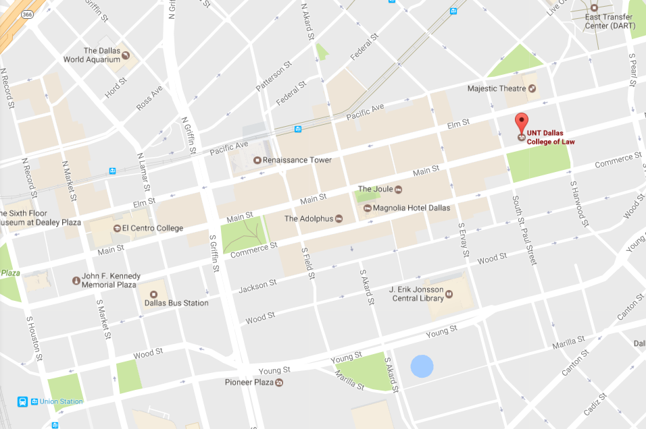

OTHER MAP

