Hotels Located Near UNT Dallas College of Law: 1901 Main St, Dallas, TX 75201
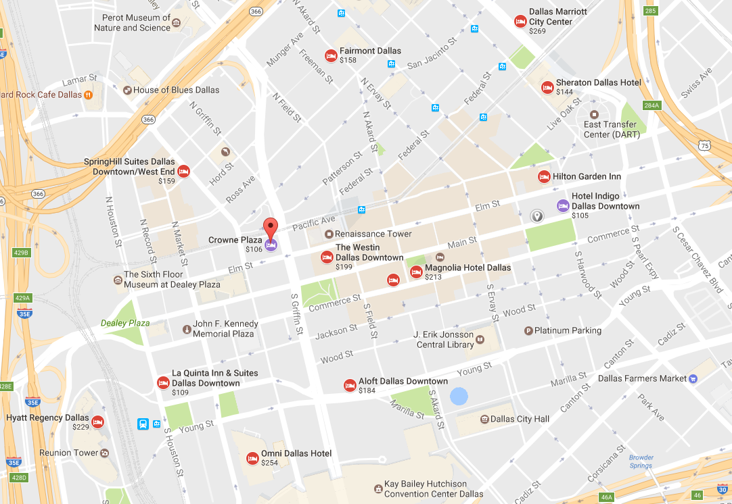
15
14
13
12
11
10
4
3
5
6
7
8
9
2
1
UNT
LAW

- Hotel Indigo Dallas Downtown – 214.741.7700
Address: 1933 Main St, Dallas, TX 75201
Distance from UNT Dallas: 269 feet
Website: ihg.com
- Hilton Garden Inn – 214.299.8982
Address: 1600 Pacific Avenue, Dallas, Texas, 75201, USA
Distance from UNT Dallas: 0.3 miles
Website: hiltongardeninn3.hilton.com
- Sheraton Dallas Hotel – 214.922.8000
Address: 400 N Olive St, Dallas, TX 75201
Distance from UNT Dallas: 0.3 miles
Website: sheratondallashotel.com
- Dallas Marriott City Center – 214.979.9000
Address: 650 N Pearl St, Dallas, TX 75201
Distance from UNT Dallas: 0.5 miles
Website: marriott.com
- Fairmont Dallas – 214.720.2020
Address: 1717 N Akard St, Dallas, TX 75201
Distance from UNT Dallas: 0.6 miles
Website: fairmont.com
- SpringHill Suites Dallas Downtown/West End – 214.999.0500
Address: 1907 N Lamar St, Dallas, TX 75202
Distance from UNT Dallas: 0.8 miles
Website: marriott.com
- Crowne Plaza – 214.742.5678
Address: 1015 Elm St, Dallas, TX 75202
Distance from UNT Dallas: 0.5 miles
Website: ihg.com

- The Westin Dallas Downtown – 972.584.6650
Address: 1201 Main St, Dallas, TX 75202
Distance from UNT Dallas: 0.4 miles
Website: westindallasdowntown.com
- The Adolphus – 214.742.8200
Address: 1321 Commerce St, Dallas, TX 75202
Distance from UNT Dallas: 0.3 miles
Website: adolphus.com
- Magnolia Hotel Dallas – 214.915.6500
Address: 1401 Commerce St, Dallas, TX 75201
Distance from UNT Dallas: 0.3 miles
Website: magnoliahotels.com
- The Joule. – 214.748.1300
Address: 1530 Main St, Dallas, TX 75201
Distance from UNT Dallas: 0.2 miles
Website: thejouledallas.com
- Aloft Dallas Downtown – 214.761.0000
Address: 1033 Young St, Dallas, TX 75202
Distance from UNT Dallas: 0.6 miles
Website: aloftdallasdowntown.com
- Omni Dallas Hotel – 214.744.6664
Address: 555 S Lamar St, Dallas, TX 75202
Distance from UNT Dallas: 0.8 miles
Website: omnihotels.com
- La Quinta Inn & Suites Dallas Downtown – 214.761.9090
Address: 302 S Houston St, Dallas, TX 75202
Distance from UNT Dallas: 1.0 miles
Website: laquintadallasdowntown.com
- Hyatt Regency Dallas – 214.651.1234
Address: 300 Reunion Blvd, Dallas, TX 75207
Distance from UNT Dallas: 1.1 miles
Website: dallas.regency.hyatt.com

